Template for Abstracts for the German Liquid Crystal Conference 2018
Lawrence W. Honaker¹, Hakam Agha^{1,2}, Emmanouil Anyfantakis¹, Vanessa Schmidt-Barbé¹ Anjali Sharma¹, Anshul Sharma¹, Shameek Vats¹, Giusy Scalia², and Jan P.F. Lagerwall¹*
¹Experimental Soft Matter Physics Group, University of Luxembourg, Luxembourg (LU)
2LC Nano Group, University of Luxembourg, Luxembourg (LU)

This is the suggested template for abstract submission for the 2018 German Liquid Crystal Conference at the University of Luxembourg, as shown in Figure 1. Please keep the following tips in mind while preparing your abstract:
· Your abstract should be not longer than one A4 page in length, with graphics (if any) taking up not more than one third of the page length. Please keep all titles to two lines or less (using bold-faced Times New Roman, 18 pt.).
· List all authors in the author list, with the presenting author underlined and the corresponding author marked with an asterisk. Number author affiliations according to the order in which the authors appear.
· We recommend citing all references in American Physics Society (APS) style, with square brackets to indicate the reference number [1]. Please cite any of your papers that may be relevant to your submission [2].
· Number and reference figures in the text of the abstract (ex. Figure 1, Figure 2...). Save the figures directly in the abstract file.

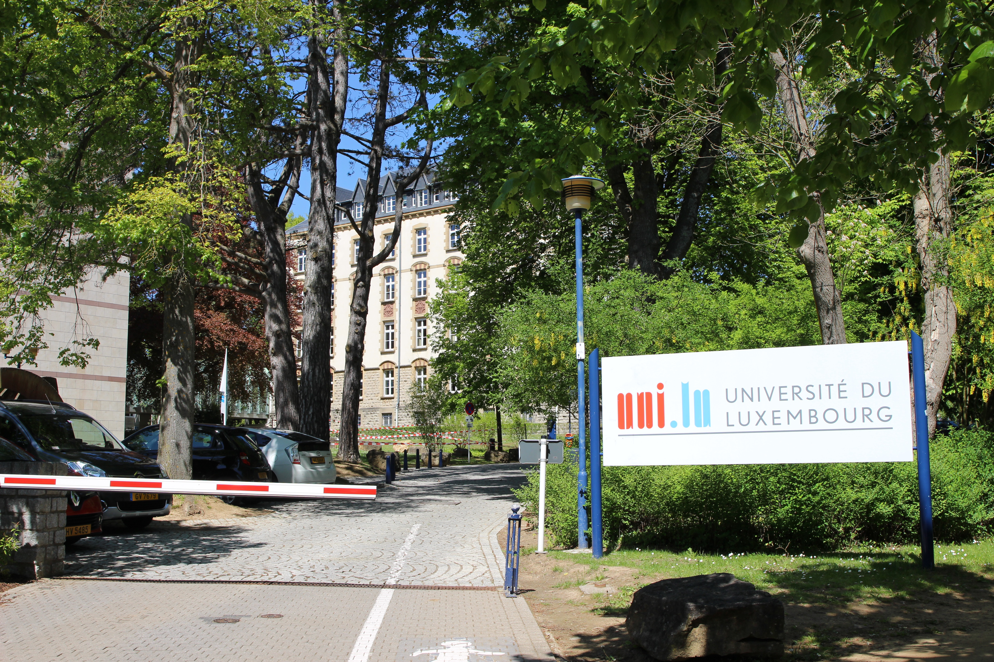
Figure 1: Campus Limpertsberg, the conference site.

Please submit your abstract as a single PDF (< 3MB in size) file no later than 15 December 2017; late submissions will receive less favorable consideration. We will value new, novel, and unpublished results more than already-published and already-presented data.

References
[1] M. Urbanski, C. G. Reyes, J. Noh, A. Sharma, Y. Geng, V. S. R. Jampani, and J. P. F. Lagerwall, J. Phys. Condens. Matter 28, 1 (2017).
[2] C. G. Reyes, A. Sharma, and J. P. F. Lagerwall, Liq. Cryst. 43, 1986 (2016).

