Template for Abstract Submissions for the
52nd German Liquid Crystal Conference

Tadej Emeršič^{1,2}, Alejandro Ibarra Orellana¹, Chih-Chieh Chien¹, and Jan P.F. Lagerwall^{1,*}
¹ Experimental Soft Matter Physics Group, University of Luxembourg, Luxembourg (LUX)
² Pritzker School of Molecular Engineering, University of Chicago, Chicago, IL (USA)
*Corresponding author e-mail: jan.lagerwall@lcsoftmatter.com

This is the template for abstract submissions for the 52nd German Liquid Crystal Conference, to be held at the University of Luxembourg 8-10 April 2026. To assist us with preparing the program, please follow the following formatting guidelines:
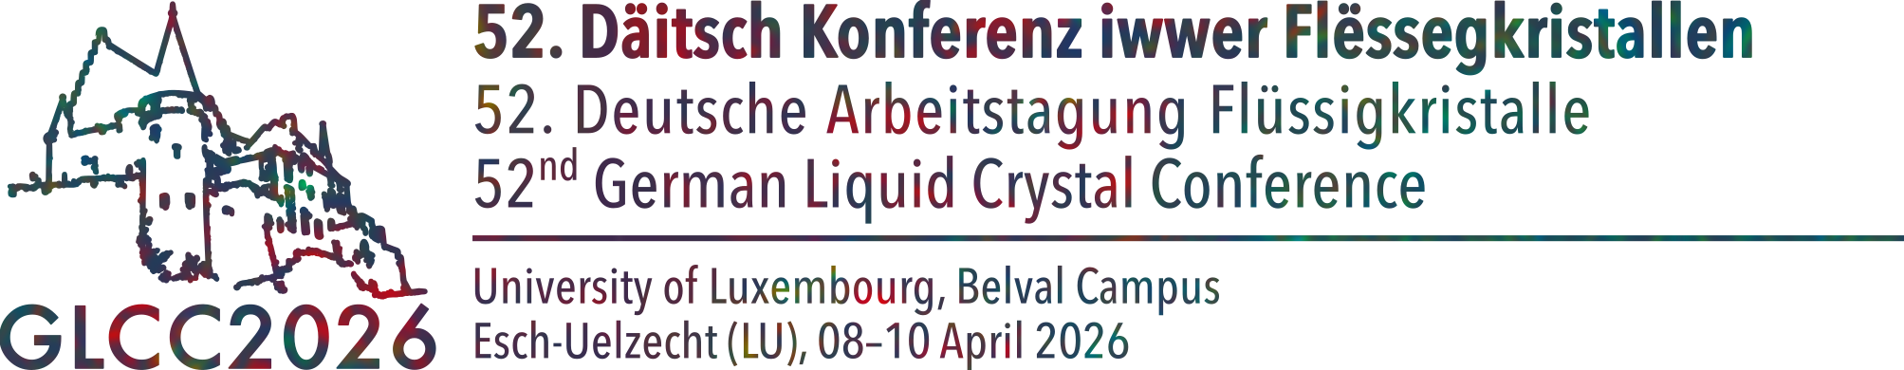
- Abstracts should be prepared on a single A4 page (210 mm × 297 mm), single-spaced, using a serif font (Times New Roman), with margins at 20 mm on all sides. Use 12 pt text for the main text and for figure captions; 10 pt text for the affiliations; and 14 pt boldfaced text for the title. Please do not use the Aptos font or fonts from the Aptos family.
- Indicate the names of the presenting author and co-authors exactly how they should appear in the book of abstracts. Underline the name of the presenting author and place an asterisk next to the name(s) of the corresponding author(s). You do not need to write full postal addresses for authors.
- Embed all figures into the file as JPG or PNG files (see Figure 1). Do not encode the figure captions directly into the figures.
- Indicate references with square brackets [1, 2], and include the references at the foot of the abstract.
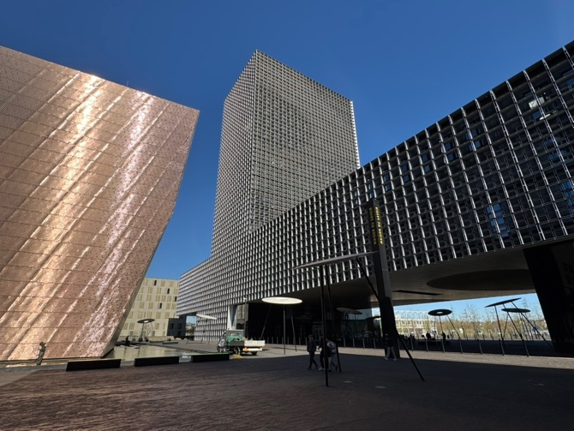
Figure 1. The Maison du Savoir of the University of Luxembourg, the venue of the 2026 German Liquid Crystal Conference.
Once prepared, please submit the abstract as a single PDF document through the GLCC website (lcsoftmatter.com/glcc2026). We will prioritize new, unpublished results over previously presented data.

References
[1] T. Emeršič, K. Bagchi, S. Fitz et al, J Phys Chem B 128, 11441–11449 (2024).
[2] N. Najiya and J.P.F. Lagerwall, Adv Optical Mater 13, 2500160 (2025).

Acknowledgments
Funding was provided by the Luxembourg National Research Fund.

